Final Report

Roman Littmann, Radek Horacek, Quinn Doyle

Safetysaurus - Smart Safe

10/13/2023

**Table of Contents**

**Introduction 3**

**Definitions 4**

**Project Detail 5**

**Circuit Diagram 6**

**Budget 7**

**Projected v.s. Actual Cost 8**

**Project Plan & Contributions 9**

**Gantt Chart 10**

**Target Market 11**

**Software architecture 12**

**Final Reflections 13**

**References 14**

# **Introduction**

We came up with the Smart Safe idea after looking for a project topic that would be both interesting and useful. We all have valuable things and items we want to keep safe. The traditional personal safes are a better choice than simply keeping the valuables on a shelf. Still, these safes can be picked by an experienced thief and safes using a PIN code can be accessed with the use of social engineering. That is why we decided to combine multiple security measurements to maximize the security of the safe.

To achieve maximum security, you should require 3 different things from the owner. The combination of them ensures the highest security. The 3 identity verification methods are

* **Something the owner physically owns**, such as the owner's ID, passport, credit card, or historically hand-written signatures. In our case, we are going to use an RFID tag that will be used by the user to verify their identity. The owner should keep the RFID tag with them at all times.
* **Something only the owner knows**, also often referred to as *Knowledge-based authentication*. This should be a piece of information that ideally only knows. Examples of this include passwords, PIN codes, and security questions. Our Smart Safe will have a numeric numpad to input a PIN code to verify the user’s identity.
* **Something that is unique to the owner and cannot be taken from them** or *Biometric authentication* is the third measurement used to provide access only to the rightful owner. Fingerprint scans or retina scans are often used for this. In our case, we will use a standard camera and a face recognition algorithm to verify the user’s identity.

# **Definitions**

**GPIO -** General-purpose Input/Output, a pin on an integrated circuit or an electronic circuit that can be used as an input, output, or both, and is controlled by software. If they are unused, they have no purpose.

**HDMI -** High-Defenition Multimedia Interface, this is a digital video connection standard that helps you get HD video on TV sets and monitors. It’s an international standard governed by over 80 countries.

**RFID -** Radio-Frequency Identification, a wireless communication system that uses electromagnetic waves to identify and track tags attached to objects, people, etc. The tags hold data that can be read by an RFID reader.

**USB -** Universal Serial Bus, a standard that was developed by several American companies as a simpler way of connecting hardware to personal computers. The USB has seen a multitude of iterations and improvements over the years.

**Ω -** Ohm, a unit of electric measure. V = volt A = ampere …………………………1Ω = 1 V/A

# **Project Detail**

The Smart Safe will make use of 3 different methods of identity verification. The goal of this project is to create a functional proof of concept prototype. The prototype will not be built with steel walls, other materials such as cardboard or polystyrene will be used instead. The result should prove that the technologies and components used were chosen correctly and that a real steel Smart Safe can be manufactured.

The safe will use an LCD to provide the user with the information and instructions regarding the lock/unlock process. We have decided to use an I2C display to lower the amount of necessary data pins. To get the input from the user, the project will utilize a USB numpad. This should allow a simple and convenient interaction with the safe. The lock mechanism will make use of a servo motor that can turn precisely at different angles. The user will also have audio feedback for their input. A 3.5mm jack speaker will be used for that purpose, the speaker may also sound an alarm if the user’s identity cannot be verified to draw attention.

The first identity verification technique is face recognition - for that, we will use a CSI interface Raspberry Pi camera. The user will present themself and the Safe will verify that the face matches the person who locked the safe.

The second security measurement is the PIN code - the user will input their secret PIN code to access the safe.

The third way to verify the real owner is the RFID tag - the user will put their RFID card in the proximity of the reader. For that, we will use an RFID module that is compatible with simple microcontrollers such as Arduino or microcomputers such as Raspberry Pi.

If the user’s identity is verified successfully, a green LED will light up and the lock mechanism will open the door of the safe. If not, a red LED will light up and an alarm will sound.

We strongly believe that implementing multiple identity verification techniques will improve the overall security of the safe and that the final product will be a simple yet secure way to store private and valuable items.

# Circuit Diagram

*The circuit diagram for the Smart Safe prototype project:*

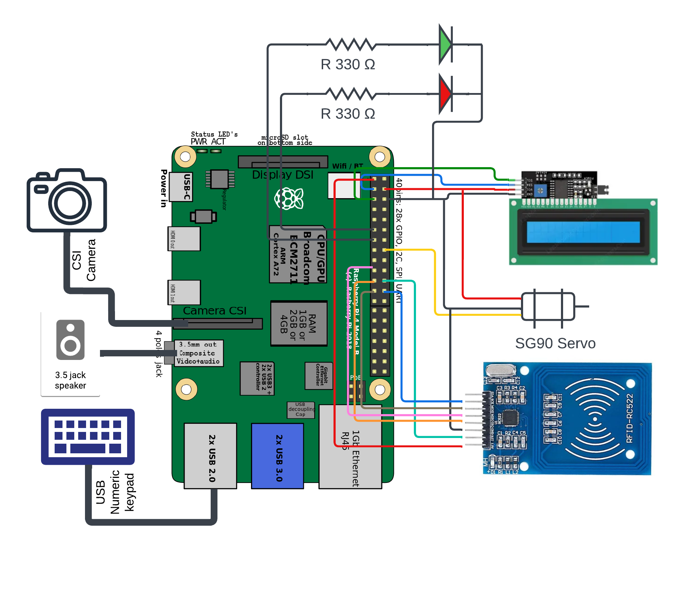

# **Budget**

| **Material** | **Cost / Item** | **Quantity** | **Total** |
| --- | --- | --- | --- |
| LCD1602 I2C Module | $2.98 | 1 | $2.98 |
| SG90 Servo motor 180[°](https://www.degreesymbol.net/) | $2.48 | 1 | $5.46 |
| 3.5mm jack speaker | $2.34 | 1 | $7.8 |
| RC522 RF IC Card Sensor Module | $2.48 | 1 | $10.28 |
| Raspberry Pi mini camera module (CSI) | $6.99 | 1 | $17.27 |
| USB Numpad | $4.48 | 1 | $21.75 |
| Other minor expenses for material (expected) | $5 | 1 | $26.75 |
|  |  | **Total For Shipping:** | $0 |
|  |  | **Total For Materials:** | $26.75 |

| **Job** | **Cost / Hour** | **Total Hours** | **Total for Labor** |
| --- | --- | --- | --- |
| Project Manager | $20.00 | 35 | $700.00 |
| Lead Developer | $18.00 | 40 | $720.00 |
| Network Engineer | $16.00 | 40 | $640.00 |
| Hardware Guru | $16.00 | 30 | $480.00 |
| Testing & Quality Assurance | $16.00 | 15 | $240.00 |
|  |  | **Total For Jobs:** | $2,780.00 |

The expected cost of this project is **$2,806.75**. That includes $26.75 for materials and $2,780.00 for labor.

# Projected v.s. Actual Cost

Below is our projected cost of labor and materials cost

| **Job** | **Cost / Hour** | **Total Hours (Proj.)** | **Total for Labor (Proj.)** |
| --- | --- | --- | --- |
| Project Manager | $20.00 | 35 | $700.00 |
| Lead Developer | $18.00 | 40 | $720.00 |
| Network Engineer | $16.00 | 40 | $640.00 |
| Hardware Guru | $16.00 | 30 | $480.00 |
| Testing & Quality Assurance | $16.00 | 15 | $240.00 |
|  |  | **Total For Jobs:** | $2,780.00 |
|  |  | **Total For Materials:** | $26.75 |
|  |  | **Total For Project:** | $2806.75 |

The table below displays the actual cost for all jobs. We ended up not categorizing any jobs as “Network Engineer” and any role that falls under that title has been taken by “Lead Developer”

| **Job** | **Cost / Hour** | **Total Hours (Actual)** | **Total for Labor (Actual)** |
| --- | --- | --- | --- |
| Project Manager | $20.00 | 13.16 | $263.20 |
| Lead Developer | $18.00 | 28.5 | $513.00 |
| Network Engineer | $16.00 | N/A | N/A |
| Hardware Guru | $16.00 | 18.33 | $293.28 |
| Testing & Quality Assurance | $16.00 | 22.16 | $354.56 |
|  |  | **Total For Jobs:** | $1,424.04 |

In total, we overestimated the cost of our project’s labor needs. We were under budget by $1382.71 when accounting for material costs.

# Project Plan & Contributions

**Project Manager** - The project manager is the organizational leader of the project. They help ensure that documents and different parts of the project are worked on. They are also responsible for making sure assignments are turned in on time.

**Lead Developer** - The lead developer is in charge of the coding aspect of the project. They are responsible for the majority of writing the code and looking for libraries if needed. They should always get help from teammates when needed, as it will make it easier to work on the code with multiple eyes looking at it for errors.

**Testing & Quality Assurance** - The person in charge of testing the prototype should try and break it. They will test for weaknesses and ensure that the project functions as intended. When bugs or weaknesses are found, the person testing the prototype will report them, and those issues will be fixed by the appropriate person.

**Network Engineer** - The network engineer will address any functionality that has to do with connecting the RaspberryPi to the network or connecting other devices to the network. They will also be in charge of troubleshooting any issues that arise with network connectivity or otherwise. Ultimately, the network engineer was a scrapped role as we didn’t have many troubles in this sector.

**Hardware Guru** - The hardware guru will order any physical parts and make sure that when they arrive, they are in working order. If there are any issues with any of the parts, then they should report that and either find a replacement part or meet with the team to alter the plan.

**Overall Contributions** - We each contributed different things to the project. Radek and Quinn did the coding and testing of parts, while Roman built the box and assembled the components in the box, as well as doing most of the administrative side of the project (writing reports and updates, etc.). Together, we all tested the final project during the last week of development and made any necessary changes at that time.

# Gantt Chart

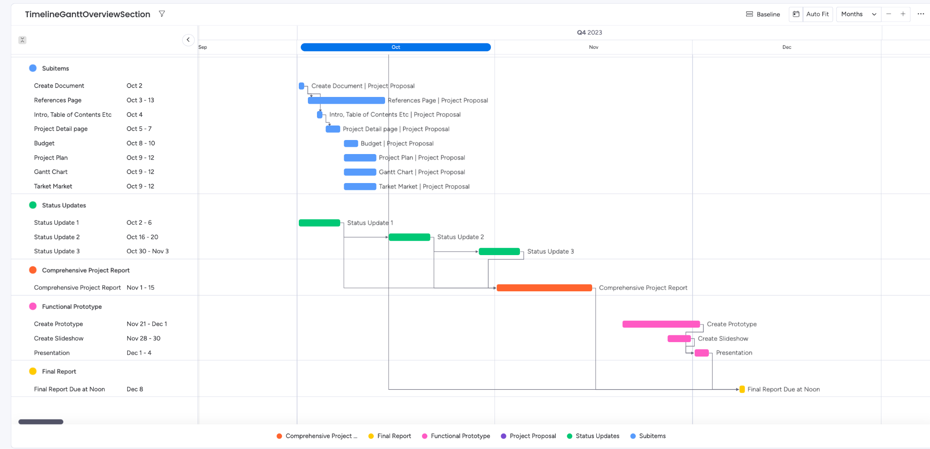

<https://qpdoyle13s-team.monday.com/boards/5315399906/>

# Target Market

Our target market is anyone who needs to protect or keep something in a secure and safe location. This could be anything; a social security card, a gun, sensitive information, or maybe just a snack you don’t want any pesky family members to steal.

The most obvious and probably the greatest market for this item would be for various security purposes. Keeping important documents inside is one of the best marketable uses of this item. We will be able to show how the safe can stay secured and protected if someone were to try and break into it. They would fail the facial recognition scan, it would be difficult to guess your unique pin, and ideally, the safe would be made out of a secure material. For the prototype, the safe will most likely be made out of cardboard to save on costs. We simply want to make sure the parts and systems work and don’t want to worry about using any metals or having difficulty working with materials.

Another possible angle we could take to marketing the product is one of fun. This would be someone wanting to secure their favorite snack to stop friends and family from gaining access. Maybe you use it to play a prank on your sibling and hide the remote inside. They’ll be turning over couch cushions for hours. Marketing a safe for this purpose at a high price point might not sell well, so it may be a good idea to take the price point down and create a different model for this purpose. The two best ways to do this would be using cheaper materials, as these aren’t being used as important safes, and to use fewer parts. This means one less security measure. These things could significantly cut costs and make it possible to sell at a lower price point, thus breaking into a different market and income bracket.

We primarily see the target market being people who want to use the product for its intended purpose: security and protection of an item(s) or information. Ideally, if we market to the wealthy or upper middle class with a substantial price point, then we are selling the idea that this is a high-end product. Considering the idea of using the product as a toy, we would have to take the marketing in a different direction and take the price point down substantially. Packaging could look different, and even color could change to sell that this is an affordable toy and not a safe to protect your personal information. We could sell to both markets, just with different strategies for each. One would show the advanced protection this safe can provide, while the other can show how fun it would be to joke around with your family and friends.

# Software architecture

The codebase was built with sustainability in mind. Thanks to two general types of modules (Security - to verify the user’s authenticity, Output - to give the user some feedback) we could utilize the principles of inheritance and polymorphism. We created such architecture that allows possible future coders to quickly understand the code and implement new features to the SmartSafe without any difficulties while maintaining high readability and quality of code. The diagram below shows the architecture of the SmartSafeUtils library that we created. This library allows convenient use and minimizes overhead and boilerplate code in the main runner.

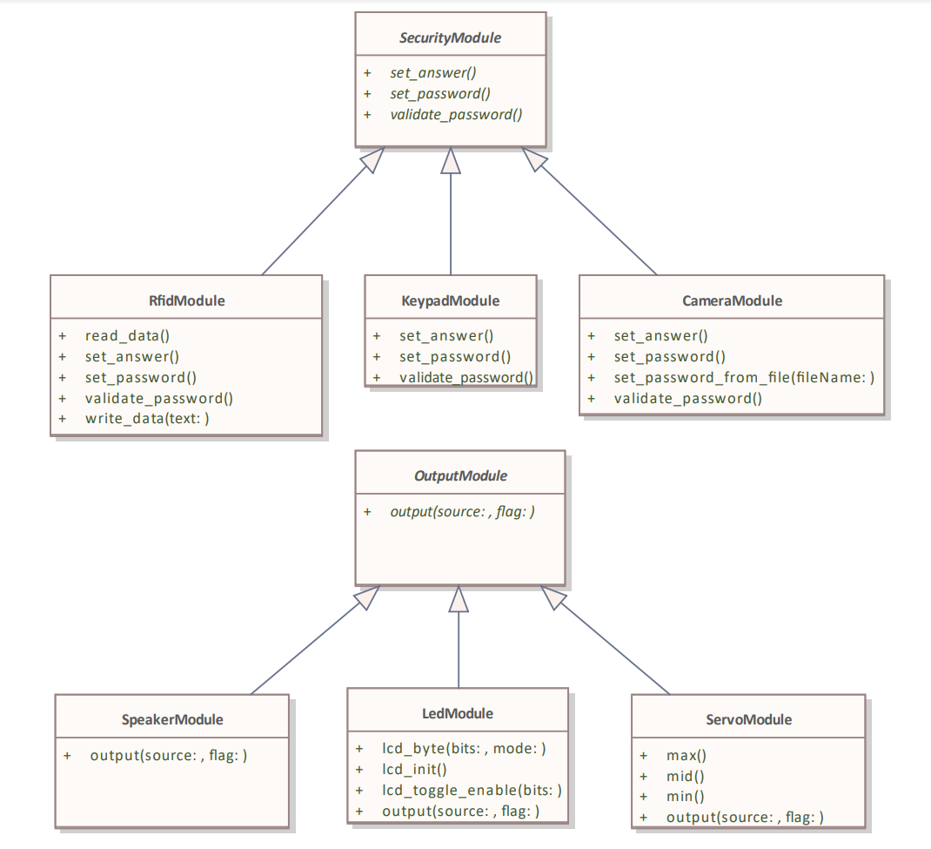

# Final Reflections

**Roman:**

Overall, we were proud of how our final prototype came out. Though it didn’t look like a perfect project, it functioned almost exactly how we wanted it to. It is a working proof of concept and we ended up achieving the goals we set for ourselves.

One challenge that we faced during the construction and testing process was getting the servo arm we had purchased to stay on the motor. It was quite weak and kept falling off. One solution we tried was melting sugar to act as glue, as we could not find any glue in the time we needed, and we feared hot glue would damage the parts. This ended up working for a bit but ultimately didn’t do a whole lot. We ended up taking off some weights that were being used to pull the safe door down, as this lessened the load on the servo arm and allowed it to stay attached for much longer. An additional challenge we faced was scheduling meetings around everyone’s schedule. If we were working at a job, this would be trivial, but working on an additional project with our schedules was a challenge. Getting together and meeting proved to be difficult. We constantly had trouble scheduling around classes and hours for other jobs. Ultimately, we did find times that worked, and we solved this problem by scheduling more in advance to block out dedicated time for the project.

Overall, this project taught us a lot about working with a team in the real world. One thing that we didn’t expect to learn about was the cost of labor. We grossly overestimated the number of hours that we would have to work on the project, ultimately predicting we would need over $1,300 more than we did.

**Radek:**

The project was a great experience for me. I learned how to work in a team with other people, how to coordinate and distribute work, and resolve issues. It also taught me how to create a functional product from scratch and make both the software and hardware parts work.

We did face multiple obstacles and difficulties while working on the project. I usually work on purely software projects, so working with hardware components and doing electrical engineering was a unique experience for me. Debugging hardware is so different and yet kind of the same as fixing software bugs. Sometimes, I was certain that I did everything correctly, but something just wouldn't work. Another challenging thing was the time management for me - not just in this class, but overall. Studying in English is much more time-intensive than if I took the same class in Czech. Working on the project generally helped with my time management and distribution abilities.

I did not have any proper coding classes this semester so coding the SmatSafeUtils library for the project helped me not forget everything about coding while learning a language that I basically never used before (Python). I am glad that I could use my knowledge of software engineering when designing the architecture of the codebase.

Overall, I am glad that I took the class and chose the topic we did. I think it was a great choice because it was doable in the time we had (although I definitely spent more time on the project than I expected). I think that it is also great that working on the project made me more comfortable with using the Linux terminal.

**Quinn:**

This project was an amazing experience for me as an intermediate programmer. I learned alot about myself as a coder and alot about how I work in a team based environment. It also greatly helped me build my confidence as a coder and software designer.

Some thing that surprised me was how quickly I could teach myself how to use a new component like the camera or LCD panel. I truly impressed myself with my own ability to adapt and problem solve with a type of coding I had never done before. I also felt that I could rely on my group mates and that I was a reliable groupmate for them. One of the biggest struggles I had to overcome was figuring out how to work the servo motor adn correctly wire it. It took some time but when I was finally able to make it work I felt so accomplished. I felt very accomplished and I felt that this project was a big step for me as a programmer and I am very pleased with how it turned out and the final result. I was also very proud to present my group and I’s hard work to the class.

# References

Edwards, B. (2022, July 12). *What is HDMI?* How-To Geek. https://www.howtogeek.com/778339/what-is-hdmi/

General-purpose Input/Output. (2023). In *Wikipedia*. https://en.wikipedia.org/w/index.php?title=General-purpose_input/output&oldid=1143571275

*In-depth: Interfacing an i2c LCD With Arduino*. (2020, November 8). Last Minute Engineers. https://lastminuteengineers.com/i2c-lcd-arduino-tutorial/

Jstrom99. (2019). *English: RaspberryPi 4B. Corrected HDMI ports, Memory and USB Decoupling Chip Labels*. Own work. https://commons.wikimedia.org/wiki/File:RaspberryPi_4_Model_B.svg

Module—Rc522—RFID/NFC Transciever. (n.d.). *DomoticX Knowledge Center*. Retrieved October 11, 2023, from https://domoticx.com/module-rc522-rfid-nfc-transciever/

*Radio-frequency identification (RFID) | Technology, History, & Applications | Britannica*. (2023, September 18). https://www.britannica.com/technology/RFID

*USB | Definition, Meaning, & Facts | Britannica*. (2023, September 13). https://www.britannica.com/technology/USB

*What is Identity Verification? | NordVPN*. (2022, November 15). https://nordvpn.com/blog/identity-verification/